**What is an analog signal?**

An analog signal is a continuous and variable electrical signal that represents information as a smoothly varying voltage or current. In the context of electronics and telecommunications, analog signals are used to convey data such as audio, video, temperature, or any other continuously variable information.

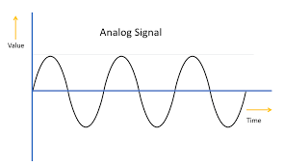

**What is digital signal?**

A digital signal is a discrete, quantized representation of information using binary code, unlike analog signals, which are continuous and vary smoothly, digital signals are composed of distinct, discrete values.

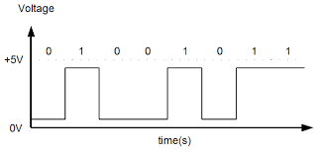

Technically, analog audio itself cannot be compressed directly because compression, as it is commonly understood, involves reducing the size of digital data by encoding it more efficiently. Analog signals are continuous and do not have a digital representation with discrete values that can be compressed.

However, in practice, when people refer to compressing analog audio, they are often talking about a two-step process:

* **Analog-to-Digital Conversion (ADC):**
  + Before compression can take place, analog audio signals are first converted into digital form using an Analog-to-Digital Converter (ADC). This process involves sampling the analog signal at regular intervals and assigning discrete digital values to represent the amplitude of the signal at each sample point.
* **Digital Audio Compression:**
  + Once the analog audio has been converted to a digital format, it can be compressed using various digital audio compression algorithms. This compression reduces the file size of the digital audio data without losing too much perceptual audio quality.
  + Popular audio compression formats for this purpose include MP3, AAC, FLAC, and others.

So, while the original analog audio itself is not compressed, the digital representation of that audio, obtained through analog-to-digital conversion, can be compressed using digital compression techniques. This is a common practice in audio recording, storage, and transmission, especially in the context of digital audio technologies.

**Why do we need ADC?**

Because analog signals are more susceptible to noise. Means noise free.

Difficult to process in analog domain.

Difficult to store in analog domain.

**How ADC works?**

The working of an ADC can be explained in 3 steps:

1.Sampling

2.Quantization

3.Encoding

**1. Sampling:** As we know that analog signal is continuous in time and continuous in amplitude. So, in the sampling stage continuous time signals are converted into discrete time signals. The sampling is done using Nyquist criteria then only we can reconstruct the original analog signal.

**what** **is Nyquist criteria?**

the sampling frequency should be >= twice the frequency of the highest frequency component in the signal(bandwidth).

The Nyquist-Shannon sampling theorem, often referred to as the Nyquist theorem or Nyquist-Shannon theorem, is a fundamental principle in signal processing and communication theory. It provides guidelines for accurately sampling analog signals to avoid loss of information during the conversion to digital form.

In mathematical terms, if fs is the sampling frequency, and *fmax is* the maximum frequency component present in the analog signal, the condition for accurate reconstruction is given by *fs* ≥2⋅*f*max

**2. Quantization:** in this stage the continuous amplitude is also converted into discrete.

Here we have to know ADC with how many no of bits. If ADC is 2-bit, then the quantization levels are raised to 2^n.

If ADC is n, then the quantization levels are 2^n.

Also, we have to know about the resolution. Resolution is defined as the minimum change in the input voltage that an adc can detect.

Resolution = VFS/2^n.

where VFS= full scale voltage

VFS = vmax – vmin

So, in quantization the sampled values are rounded to the closest discrete values.

**3. Encoding:** After quantization, the final step is to encode the quantized values into a digital format. This is typically done by representing each quantized level with a binary code. In the case of an 8-bit ADC, each level is represented by an 8-bit binary number. The encoding process assigns a binary code to each quantized level, forming a digital representation of the analog signal. The encoded digital values can then be further processed, stored, or transmitted by digital systems.  
  
Overall, the working of an ADC involves converting continuous analog signals into discrete digital values through the stages of sampling, quantization, and encoding. It enables the conversion of real-world signals into a digital format that can be processed, analyzed, and utilized by various digital systems and applications.

**NOTE: Audio sampling rate is a fundamental parameter that directly impacts the Fidelity and accuracy of digital audio recordings. Sampling rate is the major thing in analog to digital conversion.**

**What are AUDIO FILE FORMATS?**

Audio file formats are utilized to store and organize audio data in digital form.

**1.WAV(waveform):**

Supports high quality audio.

Uncompressed format, hence larger file sizes make it less suitable for limited storage spaces.

**Commonly used** for professional audio applications.

**2.MP3:**

The most widely used audio file format, known for its efficient compression algorithm.  
 Designed to reduce file size  
 Lossy compression technology

**Used in** audio players, devices and os.

# **Audio compression**

Audio compression is a technique used to reduce the size of audio files without significantly affecting the perceived audio quality. It works by encoding the audio in a way that removes unnecessary or redundant information, reducing the overall file size.

**Lossless Compression:**

In lossless compression, the original data can be perfectly reconstructed from the compressed version. No information is lost during the compression process.

Examples: ZIP

FLAC

**Lossy Compression:**

In lossy compression, some data is discarded during the compression process, resulting in a smaller file size but a slight loss of quality.

Examples: MPEG

JPEG

**3.AAC (advanced audio coding)**

Developed as the successor to MP3, AAC provides higher sound quality at lower bit rates.  
Possesses improved compression efficiency, delivering better audio fidelity.  
**Commonly used** in online streaming platforms, digital television, and mobile devices.  
Apple uses AAC as the default format for its iTunes Store.,youtube

**4.FLAC (Free lossless Audio Codec):**

FLAC (Free Lossless Audio Codec) is a lossless compression format designed to reduce the file size of audio data without sacrificing any quality.

**Used in** various operating systems, media players.

**5.OGG (ogg vorbis):**

Open-source and free format.

Lossy compression with good audio quality.

Often used for streaming and online distribution like gaming, web applications and multimedia development.

**NOTE:** **Choosing the appropriate format is crucial to achieving the desired balance between audio quality and file size.**

The "best" format depends on factors such as:

* **Use Case:** Streaming, archiving, editing, etc.
* **Audio Quality:** Whether lossless or lossy compression is acceptable.
* **File Size:** Storage and bandwidth considerations.
* **Device Compatibility:** Some formats may be more widely supported on different devices and platforms.

|  |  |  |  |
| --- | --- | --- | --- |
| **Type of format** | **Compression mode** | **Audio quality** | **File size** |
| Wav | No compression | High quality | Large size |
| MP3 | lossy | Acceptable quality | Good balance between quality and size |
| AAC | lossy | high | small |
| FLAC | lossless | high | Large compared to mp3 |
| OGG | lossy | high | small |

**What is Bitrate?**

Audio bitrate, often simply referred to as "bitrate," is a measure of the amount of data used to represent one second of audio in a digital file. It is typically expressed in bits per second (bps) or kilobits per second (kbps). Bitrate is a crucial parameter in digital audio encoding, representing the level of compression applied to the audio data.

In the context of digital audio, higher bitrates generally result in higher audio quality but also lead to larger file sizes. Conversely, lower bitrates result in smaller file sizes but may compromise audio quality due to greater compression.

**What is Bit depth?**

It refers to the number of bits used to represent each sample of audio or pixel of an image. Bit depth plays a crucial role in determining the dynamic range and precision of the digital representation.

In the context of digital audio:

* **Bit Depth in Audio:**
  + Bit depth is the number of bits used to represent the amplitude of each sample in a digital audio signal.
  + Common bit depths in audio include 8-bit, 16-bit, 24-bit, and 32-bit. The higher the bit depth, the greater the dynamic range and precision.
* **Dynamic Range:**
  + Dynamic range is the difference between the quietest and loudest parts of an audio signal. Higher bit depths allow for a wider dynamic range, capturing more subtle variations in volume.

**Resolution:**

* Bit depth contributes to the resolution of the audio signal. Higher bit depth results in finer resolution and more accurate representation of the original analog waveform.

**What is DAC?**

The Digital-to-Analog Converter (DAC) plays a crucial role in converting digital signals into analog signals for various applications, such as audio playback. The working principle of a DAC involves translating discrete digital values into a continuous analog waveform. Here is a simplified explanation of how a DAC works:

* **Digital Input:**
  + The process begins with a digital input, typically represented by binary code (0s and 1s). This digital input can come from various sources, such as digital audio files, communication systems, or sensors.
* **Sampling:**
  + In the context of audio signals, the digital input often represents a sampled version of an analog waveform. The original analog signal is sampled at regular intervals, and each sample is represented by a binary code. The rate at which these samples are taken is known as the sampling rate.
* **Quantization:**
  + The binary code for each sample is determined by quantization. Quantization involves assigning a digital value to each sample, representing its amplitude. The number of bits used for quantization determines the resolution of the digital signal. For example, a 16-bit DAC can represent each sample with one of 2^16 (65,536) possible values.
* **Digital-to-Analog Conversion:**
  + The quantized digital values are then processed by the DAC to generate an analog output. This involves converting the discrete digital values into a continuous analog waveform that can represent the original audio signal.
* **Reconstruction Filter:**
  + In some DAC designs, a reconstruction filter may be used to smooth the output waveform and eliminate high-frequency components introduced during the sampling process. This helps in reconstructing a more accurate analog signal.
* **Analog Output:**
  + The final output of the DAC is an analog signal that can be sent to amplifiers, speakers, or headphones for playback.

**What is an Audio amplifier?**

An audio amplifier is an electronic device that increases the amplitude (volume) of an audio signal, making it suitable for driving speakers or headphones. The primary function of an audio amplifier is to take a weak input signal, such as that from a musical instrument, microphone, or audio source, and amplify it to a level sufficient to drive the speakers or headphones and produce sound audible to the listener.

**Pre silicon testing?**

Pre-silicon testing refers to the testing and verification processes performed before the actual manufacturing or fabrication of semiconductor devices, commonly known as silicon chips or ICs (Integrated Circuits). This phase of testing is crucial in identifying and resolving potential design issues, ensuring the functionality and reliability of the chip design before it goes into production. Pre-silicon testing is an integral part of the overall semiconductor design.

**Post silicon testing?**

Post-silicon testing refers to the testing and validation processes performed after the semiconductor devices, such as integrated circuits (ICs) or silicon chips, have been manufactured. This phase of testing is crucial to ensure that the fabricated silicon devices meet the specifications, performance criteria, and reliability standards set during the design phase. Post-silicon testing aims to detect and address any issues that may arise during the manufacturing process, including defects, variations, and other factors that can affect the functionality and performance of the chips.

**Watchdog Timer?**

**The watchdog timer acts as a fail-safe mechanism that can save a system from becoming permanently unresponsive.**

The watchdog timer is a hardware component designed to monitor the proper functioning of a system and initiate corrective measures if the system fails to respond within a specified timeframe.

Here's what typically happens when a watchdog timer reaches 0:

* **Timeout Occurs:**
  + The watchdog timer is initially set with a specific timeout period or countdown interval. During normal operation, the system's software is responsible for periodically resetting or "feeding" the watchdog timer within this interval.
* **Failure to Feed:**
  + If, for any reason, the system fails to feed the watchdog timer within the specified interval, the countdown timer within the watchdog hardware continues to decrement.
* **Watchdog Timer Reaches 0:**
  + When the countdown timer reaches 0 (zero), it indicates that the system has not been properly responding or feeding the watchdog within the expected timeframe.
* **Watchdog Action:**
  + Upon reaching 0, the watchdog timer initiates a predefined action. The most common action is to trigger a system reset. This reset is intended to recover the system from a potentially malfunctioning or unresponsive state.
* **System Reboot:**
  + The system is forced to reboot as a result of the watchdog timer reaching 0. During the reboot process, the system goes through its startup sequence, initializing hardware, loading the operating system, and resuming normal operation.

The purpose of the watchdog timer is to add a layer of fault tolerance to a system. It automatically detects and responds to situations where the system becomes unresponsive, hangs, or experiences other failures. The watchdog timer provides a fail-safe mechanism to recover the system from such conditions and ensure continued operation.

**OTP (one time programmable)?**

n embedded systems, OTP (One-Time Programmable) refers to a type of **non-volatile memory** that can be programmed only once, and its content cannot be modified or erased thereafter. OTP memory is commonly used to store data that needs to be preserved across power cycles or system resets, such as configuration settings, security keys, or device-specific information.

**Applications in Embedded Systems:**

* OTP memory is commonly used in embedded systems for storing device-specific information, serial numbers, calibration data, security keys, and other configuration settings. These are values that need to be set during manufacturing and remain fixed throughout the device's lifetime.
* Security and Tamper Resistance: OTP memory can be used to store cryptographic keys and other security-related information. Since the data is non-modifiable, it can resist tampering attempts aimed at altering or stealing the stored information.
* Configuration and Calibration: OTP memory is commonly used to store configuration settings and calibration data for devices and systems. These settings can be set during manufacturing or initialization and remain fixed throughout the device's lifetime.

**Cryptographic keys** are essential components in cryptography, a field that deals with secure communication and information protection. Cryptographic keys are used to perform various cryptographic operations, such as encryption, decryption, digital signatures, and authentication. These keys are crucial for ensuring the confidentiality, integrity, and authenticity of data in secure communication systems.

**Application Examples**: OTP memory is used in various applications such as microcontroller boot code, device identification, secure key storage, system configuration, and more.

## **FPGA**

FPGA stands for Field-Programmable Gate Array. It is a type of integrated circuit (IC) that can be programmed and configured by the user after manufacturing. FPGAs are designed to be highly flexible and can be reconfigured to perform various tasks, making them valuable tools for a wide range of applications, from digital logic design to signal processing and beyond.

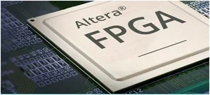

**Reconfigurability:** FPGAs can be programmed and reprogrammed to implement custom digital circuits, allowing designers to create hardware tailored to specific tasks. This makes them versatile and adaptable to changing requirements.

**Hardware Description Languages (HDLs)**: FPGAs are typically programmed using HDLs like Verilog or VHDL. These languages allow designers to describe the desired functionality of the circuit using a hardware-centric approach.

**Parallel Processing:** FPGAs can be used to create custom parallel processing architectures, making them suitable for tasks that require high computational throughput, such as signal processing, cryptography, and data analysis.

**WHAT IS PACKAGE?**

The external cover of an ic is called package.

**NEED of IC PACKAGES?**

**why ic’s are packaged instead of directly soldered on the surface of the circuit board?**

**Basic needs of packages:**

Ics requires protection

Electrical connection

Heat dissipation

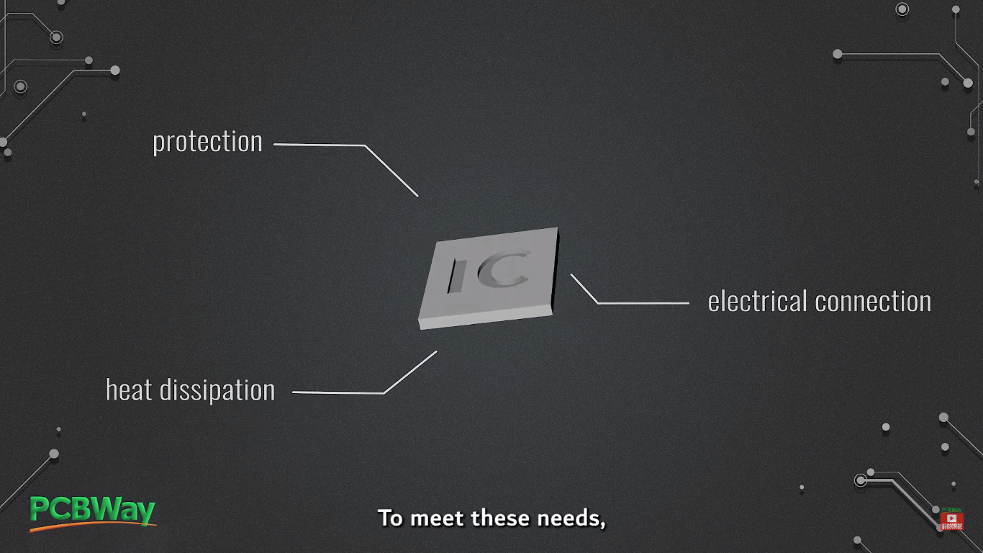

To meet the above needs ic packages serves as a crucial role

These packages not only safeguard the ics from environmental factors but also provide the necessary electrical connections and heat dissipation.

**Types of packages:**

1.QFN

2.CSP

**QFN:** QFN stands for quad-flat- no leads

Characterized by rectangle or square shape.

QFN package consists of bond wire, lead frame, silicon die and exposed pad, die attach.

Among them the silicon die, lead frame and solder pads are the crucial components.

The die is the actual integrated circuit chip, and it contains the electronic circuitry of the IC.

The lead frame provides electrical connections between the die and the rest of the QFN structure.

The solder pads are used to connect the package to the circuit board improving the package's thermal performance.